**Installation manual**

Create new folder in your local as SiteCore folder, and clone the source code into this folder. To clone from the repo please use this url <https://github.com/rajakamil4/SingleSignOn.git>, choose branch master. And the source code can be be viewed at <https://github.com/rajakamil4/SingleSignOn>.

Clone as below

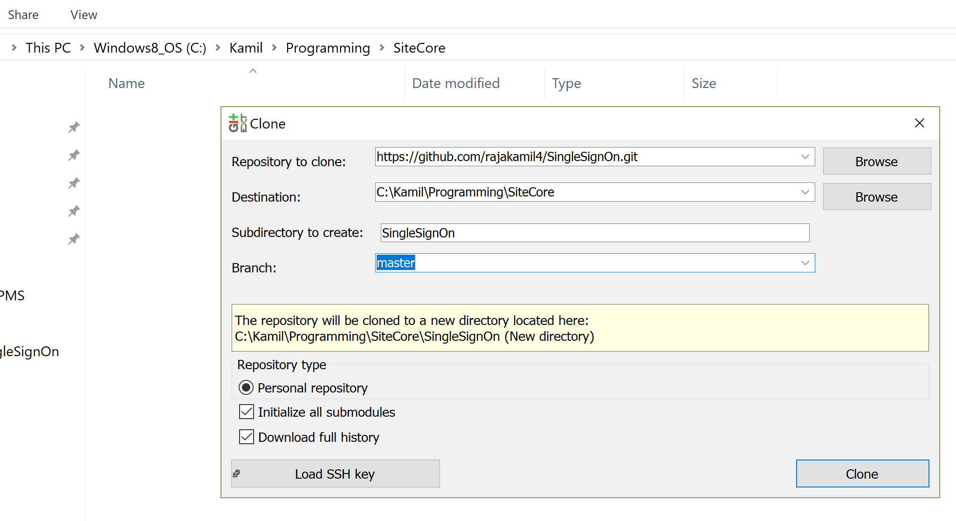

There are six folders after the clone finished as below

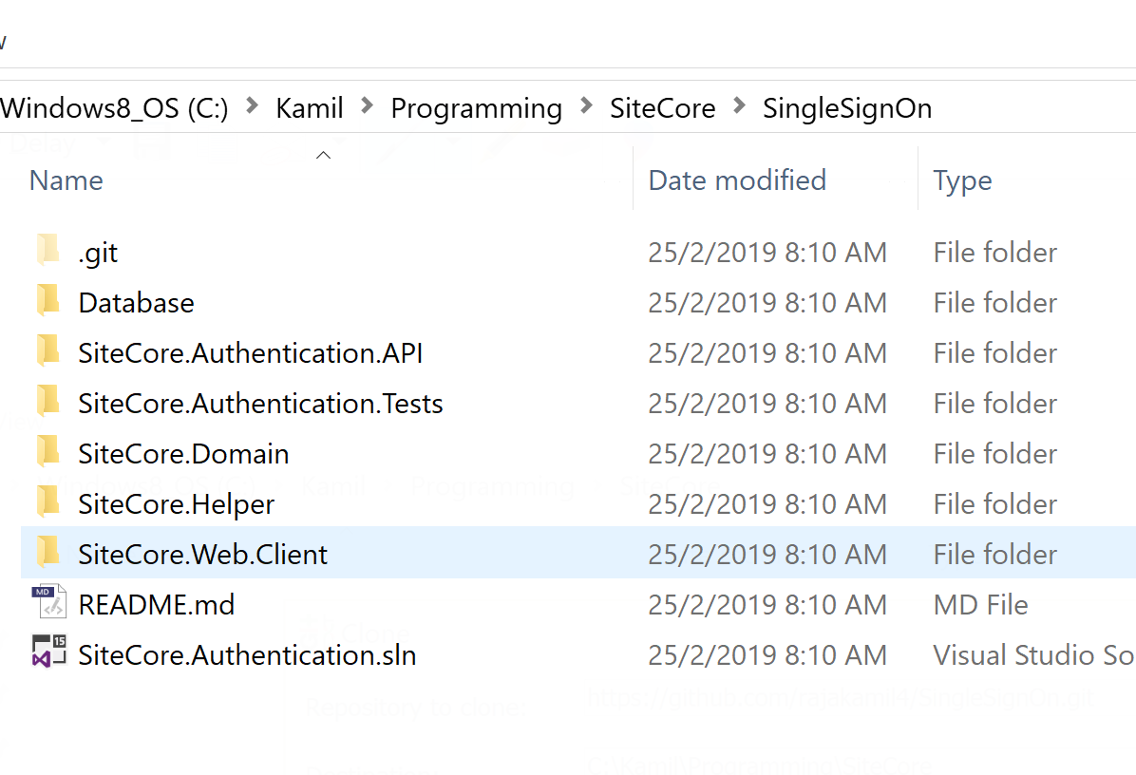

Open the solution file (.sln) using Visual Studio 2017.

There are 5 projects in the solution explorer as below

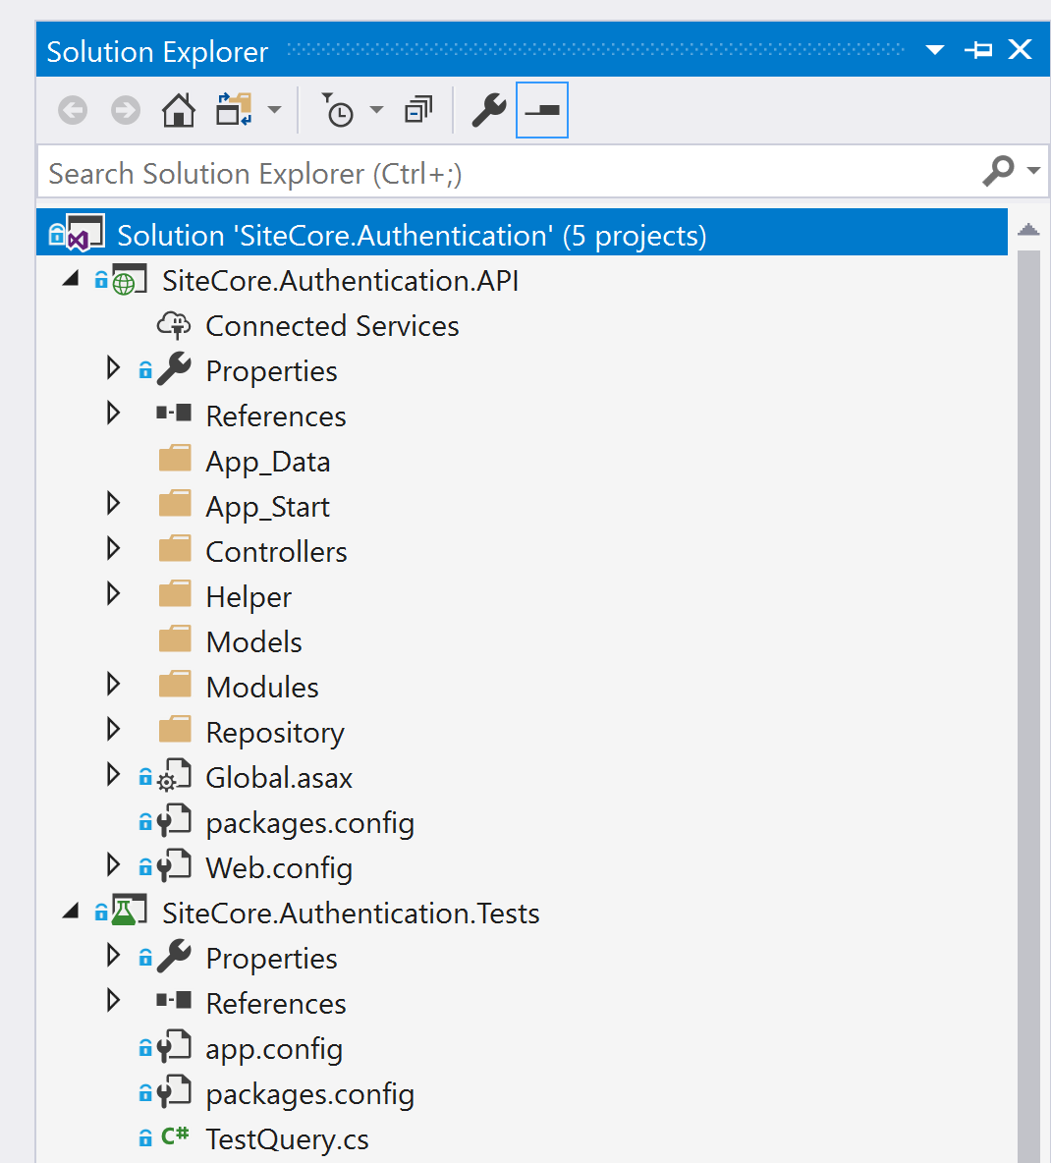

And build this solution file, after all these 5 projects successfully build

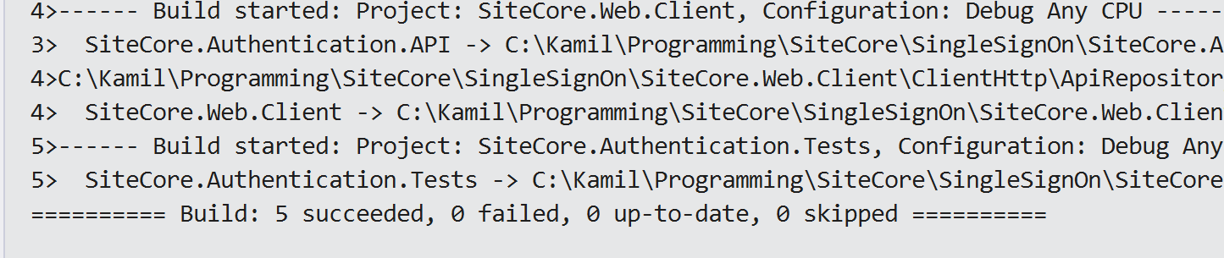

Set the SiteCore.Web.Client project as “Set as Startup Project”.

Go back into windows explorer and open Database folder and you can find 2 database files as below

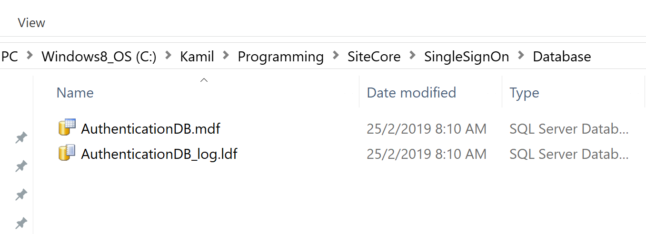

And attach these 2 files (.mdf and .ldf) in SQL Server Management Studio. After attach the database complete go back to Visual Studio and focus to project **SiteCore.Authentication.API**.

This project is the Web API for authentication exercise, and where the only project that involved with database (MS SQL Server).

Open **Web.config** under this project

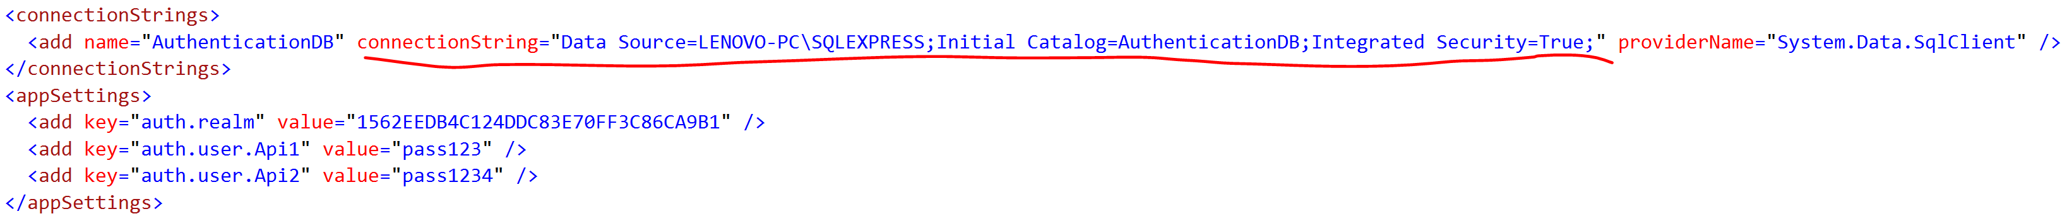

Please edit this connection strings to reflect your local database connection and save. And please make sure this Web API have read and write permission in SQL Server using NT AUTHORITY\NETWORK SERVICE if you are using Integrated Security in the connecting string

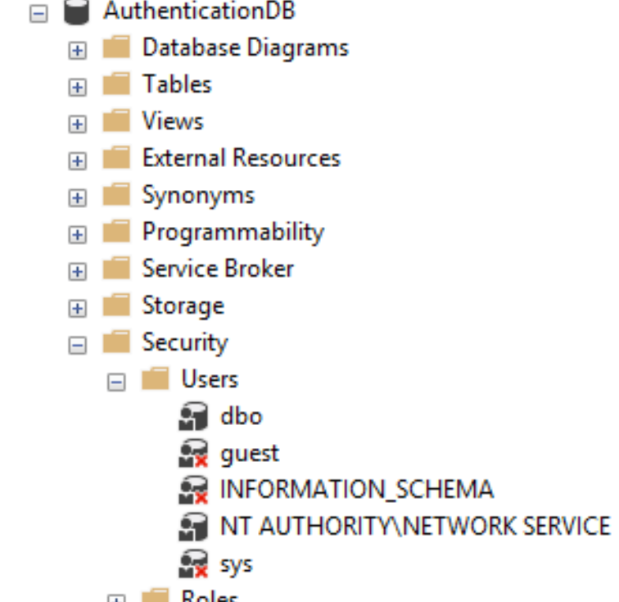

This project **SiteCore.Authentication.API** need to be deployed in IIS web server in order to test this API.

Open your **Internet Information Services (IIS) Manager** and under **Default Web Site** 🡪 **Add Application**

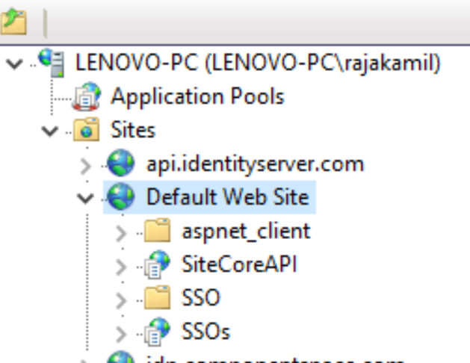

You can **Add Application** as below

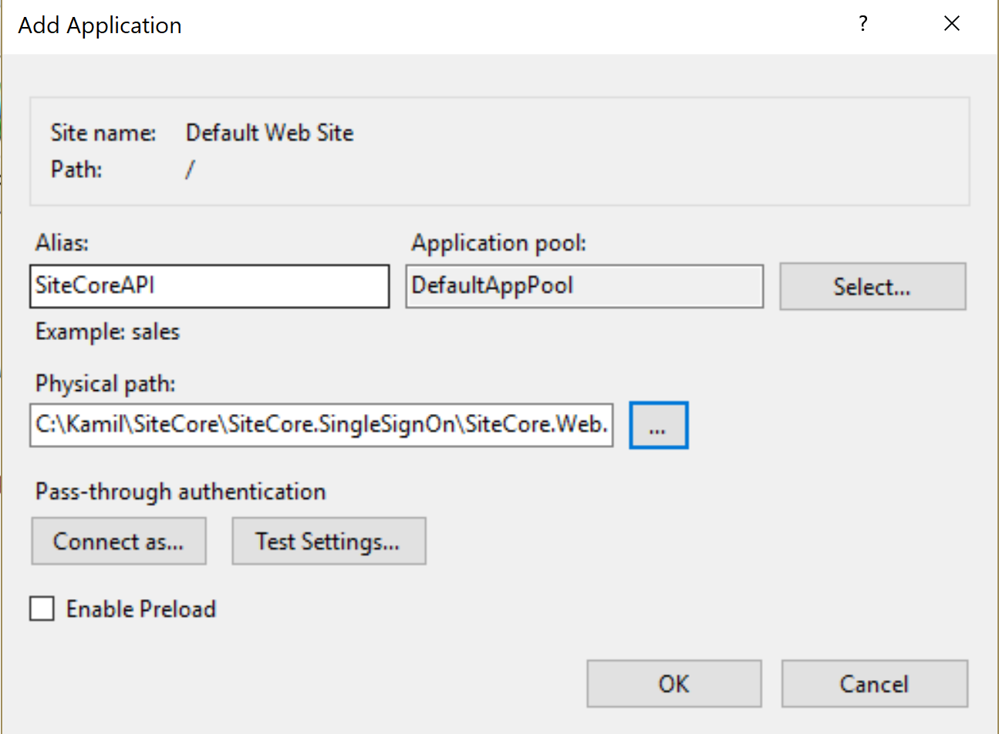

And the Physical path you need to browse your local and select **SiteCore.Web.Client**. And please test and run this website without error, the URL of this Application is to be [**http://localhost/SiteCoreAPI**](http://localhost/SiteCoreAPI)

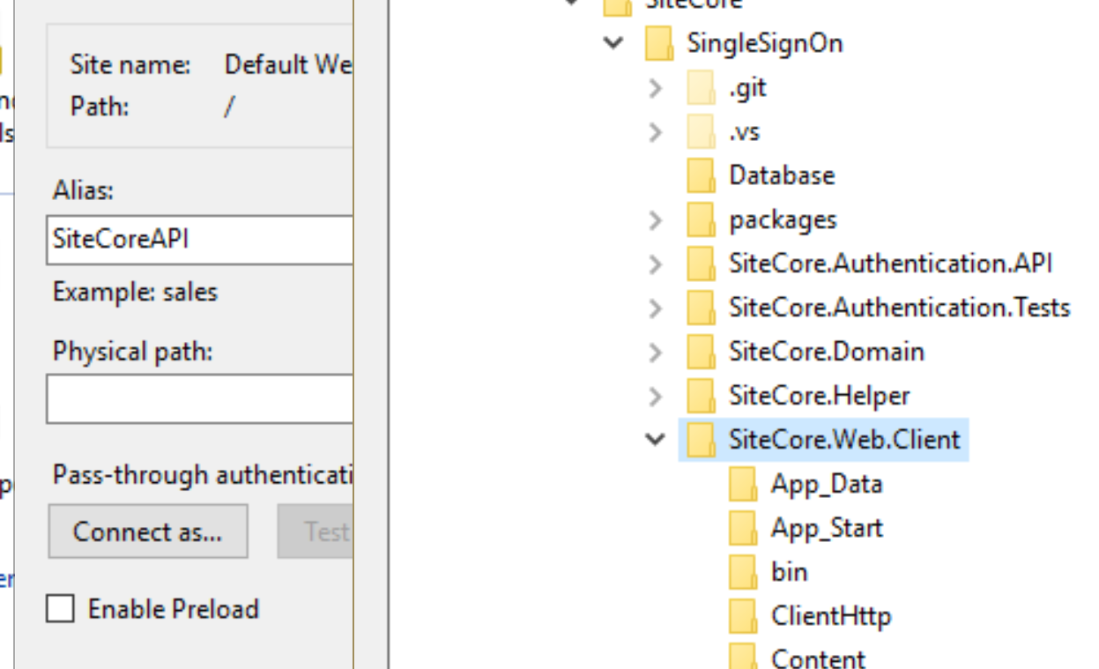

Go back to your Visual Studio and focus on project **SiteCore.Web.Client**. Open **Web.config** file under this project and search for appSettings as below

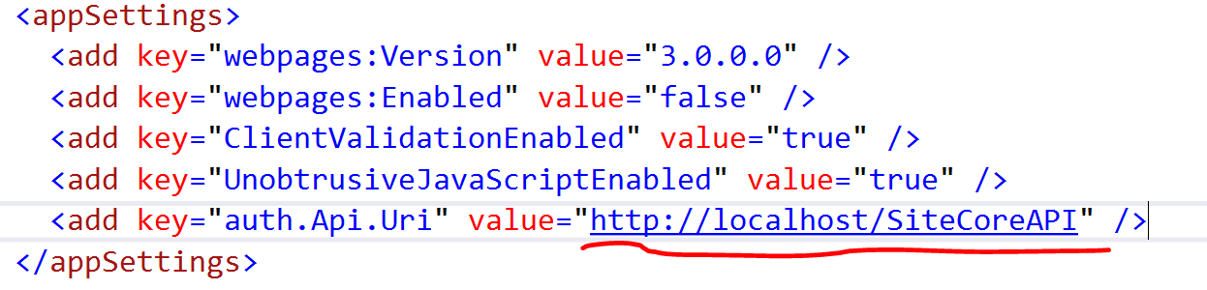

Please make sure this value [**http://localhost/SiteCoreAPI**](http://localhost/SiteCoreAPI)is the same with the URL u have setup in IIS before.

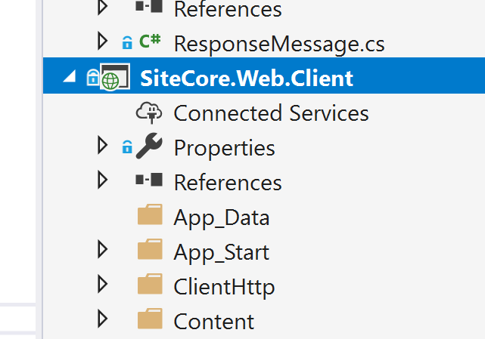

Save and the run this project in Visual Studio, and the browser should open as below

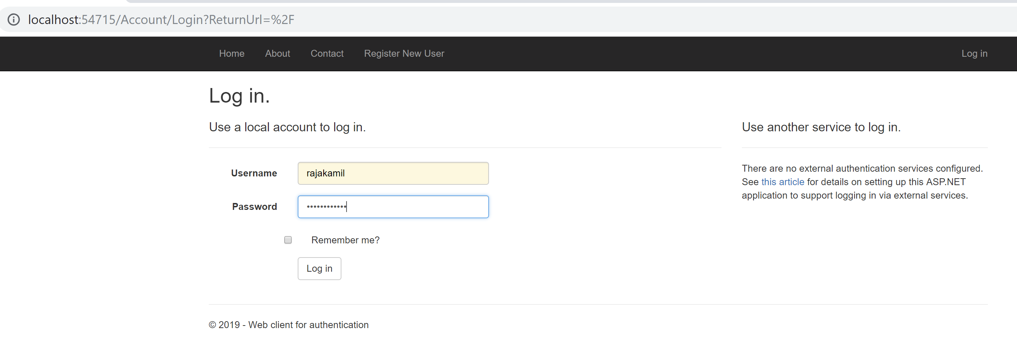

Please refer User Manual to navigate this system